AI ASSITED CODING

ASSIGNMENT 2.2

NAME:N.KEERTHI REDDY

ROLL NO:2403A52376

BATCH:14

Task Description#1  
● Use Gemini in Colab to write a function that filters out all negative numbers from a  
given list

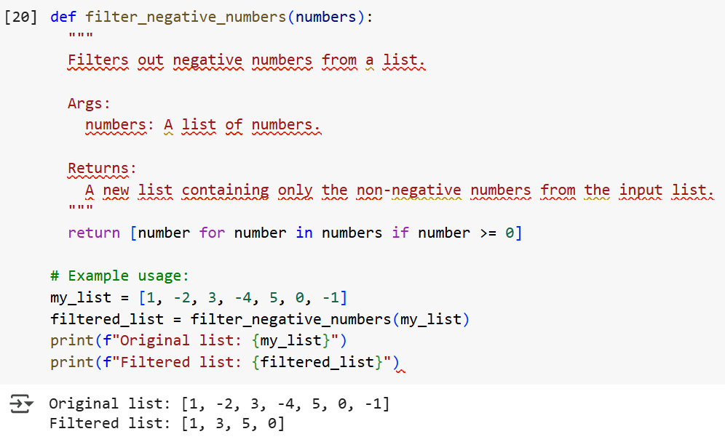

Task Description#2  
● Ask Gemini to generate code that reads a text file and counts the frequency of each  
word. Then ask it to explain the code.

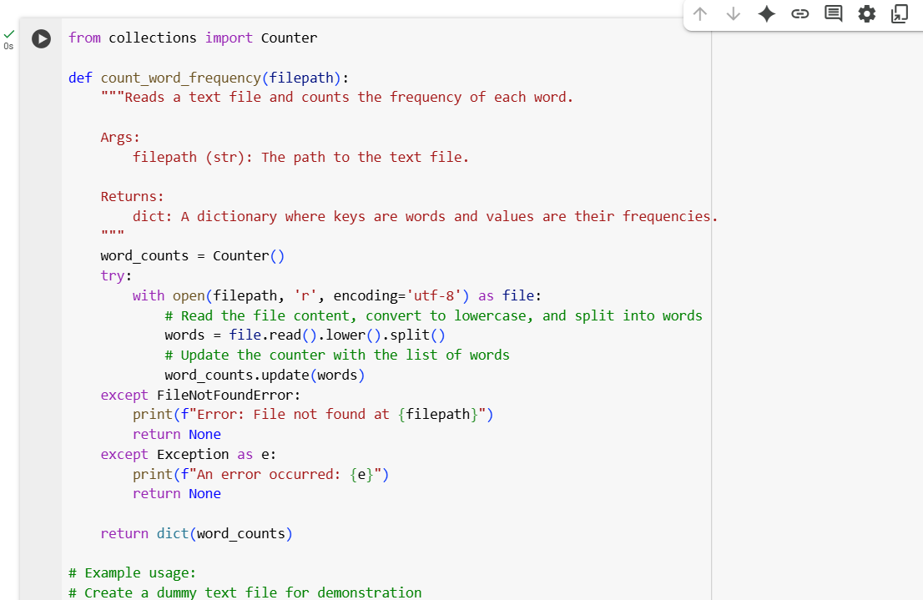

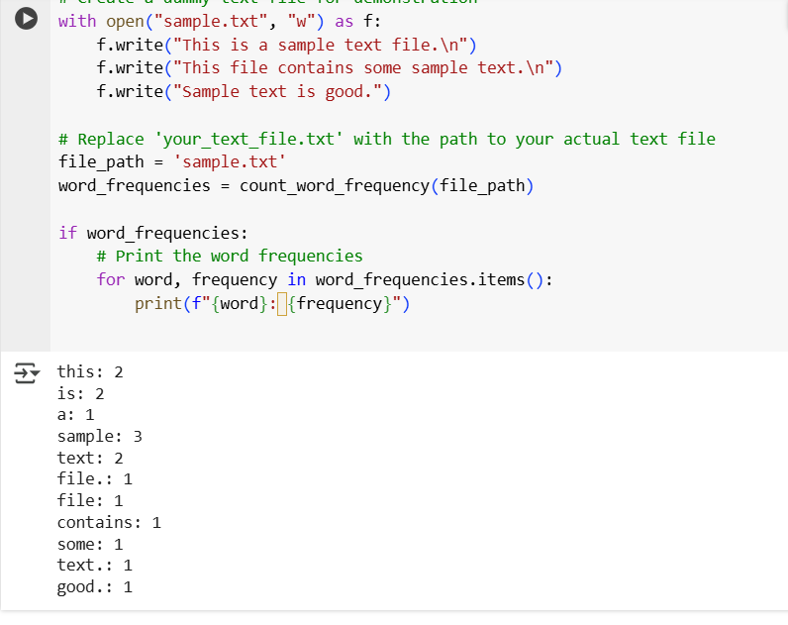

Task Description#3  
● Use Cursor AI to generate a Python class called Book with attributes title, author, and  
a method summary() that prints the detai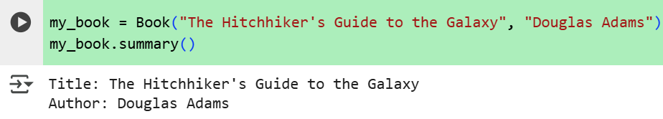

Task Description#4  
● Ask Gemini to write a program that checks whether a number is an Armstrong  
number, and then modify it using Cursor AI to improve performance or structure

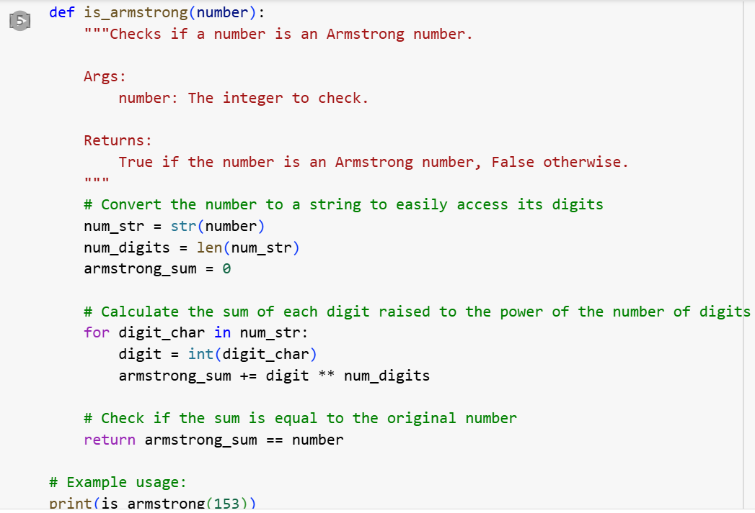

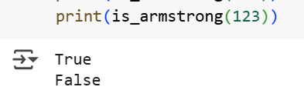

Task Description#5  
● Use both Gemini and Cursor AI to generate code for sorting a list of dictionaries by a  
specific key (e.g., age).

